Office Use Only
Date Received: _____________________________________
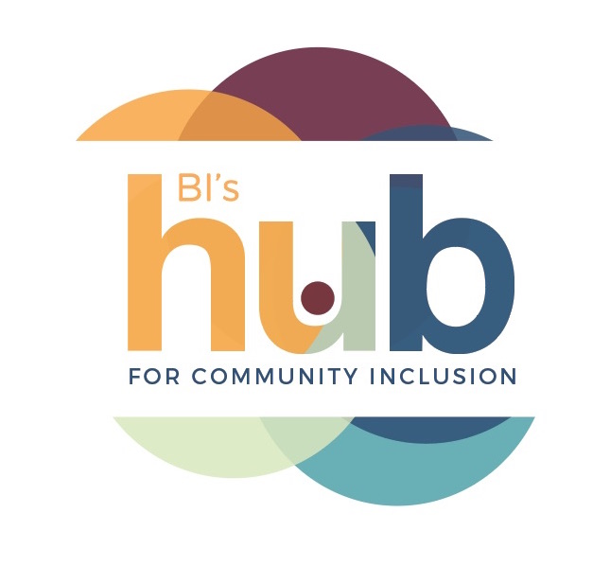
Behaviour Innovations’ Hub Day Program
INTAKE FORM
Thank you for your interest in Hub Day Program! Prior to admission to Hub day program, participants must attend a brief no-cost intake meeting (around 30-60 minutes) with the day program coordinator and/or psychologist. The potential participant must attend with their parent/guardian. After the intake meeting, the participant will be scheduled for a trial day with the level of support determined in the intake meeting. An attendance schedule and level of support is decided on after the trial day.

Participant Information
What school or day program is the participant currently attending? _______________________________________________________________________________________________________________________________
What level of support is the participant receiving at school or day program? _______________________________________________________________________________________________________________________________
Does the participant have any types of challenging behaviours? ☐ NO ☐ YES
If yes, please check of all that apply: ☐ Self-Injurious Behaviour ☐ Property Destruction ☐ Pacing ☐Bolting/Elopement ☐ Aggression ☐Repetitive Behaviour ☐Other:_____________________________________________

How does the participant communicate? (Please check all that apply)
☐Speech ☐Signs ☐PECS ☐Gestures ☐AAC Device (i.e. iPad/Dynavox) ☐Writing
☐Other: ____________________________________________________________________________________________________________________

Does the participant have any mobility concerns (i.e. assistive devices)?
☐ NO ☐ YES: _____________________________________________________________________________________________________________

Does the participant have any medical conditions that may impact his/her ability to engage in physical activity or community outings (i.e. epilepsy, previous surgery)?
☐ NO ☐ YES: ____________________________________________________________________________________________________________

Contact Information
Participant’s Name: ______________________________________________________________________________________________________ Date of Birth: __________________________________________ Age: __________________ Gender: ☐M ☐ F Other: ___________
Address (if different from parents’ below):_____________________________________________________________________________

Parents’/Guardians’ Names:______________________________________________________________________________________________ Address:____________________________________________________________________________________________________________________ City/Town:_______________________________________________________________________ Postal Code:___________________________
Telephone (Home): _____________________________________________________________
Phone (Cell): _____________________________________________________________________
Email:_____________________________________________________________________________

Office Use Only
The no-cost initial appointment at HUB is confirmed for _______________________________________________________________________________at ________________________am/pm at ☐ OAKVILLE DAY PROGRAM or ☐TORONTO HUB DAY PROGRAM.
Availability/Scheduling
How frequently would you like the participant to attend?
☐ 1-2 days/week ☐ 3-4 days/week ☐ Full Time ☐ Summer Exclusive ☐ Other: _____________________________

Preferred Program Location: ☐Oakville ☐Toronto
How did you hear about Hub Day Program? _______________________________________________

